User Guide

### Installation

Download our project from <https://github.com/2020-IRS-G12/FraudulentJobClassifier>

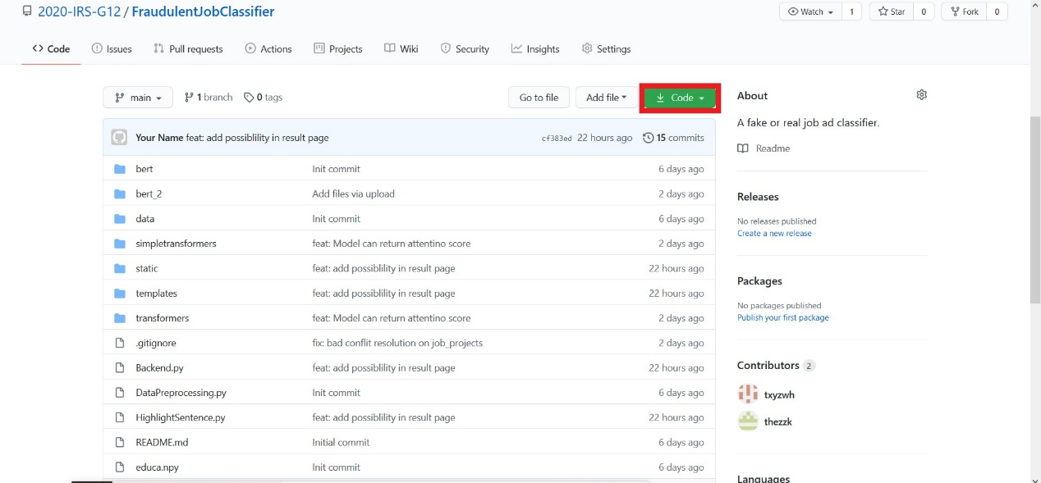

###### Install python 3.7.7

<https://www.ics.uci.edu/~pattis/common/handouts/pythoneclipsejava/python.html>

###### Install package:

pip install matplotlib

pip install tensorflow==2.2.0

pip install transformers

pip install simpletransformers

pip install flask

pip install seaborn

pip install nltk

pip install imblearn

pip install spacy

python -m spacy download en_core_web_sm

pip install torch==1.6.0+cpu torchvision==0.7.0+cpu -f <https://download.pytorch.org/whl/torch_stable.html>

open this link: <https://1drv.ms/u/s!AmyxNOLc-OSajGBZQknjpz8n4toM?e=gzxINy>

Download those two files.

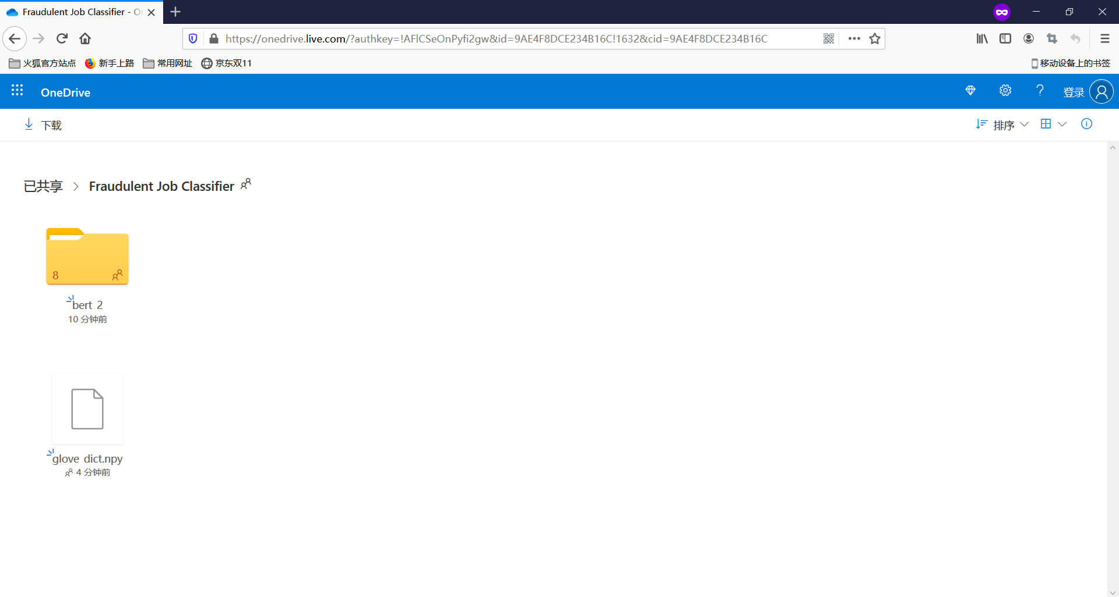

Copy these two folder to your **FraudulentJobClassifier**

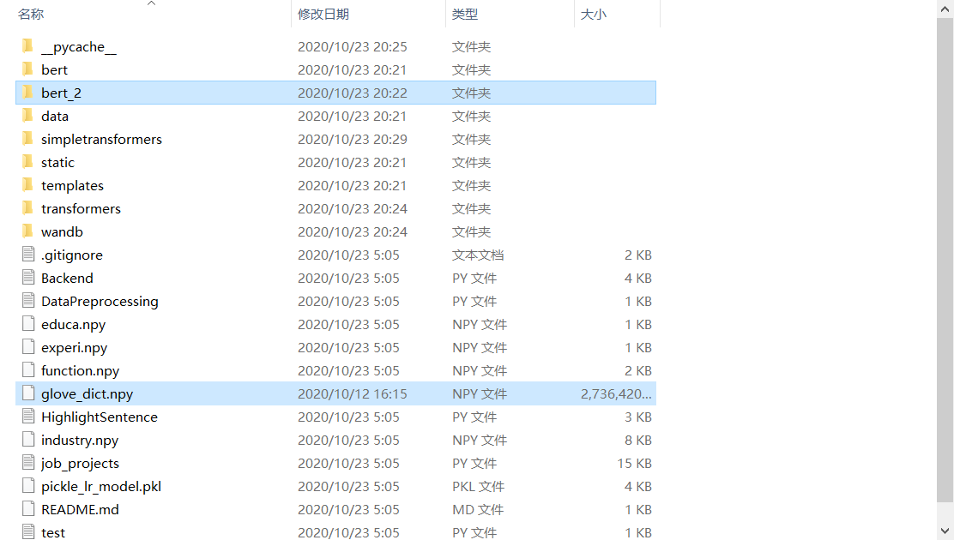

##### Run project

Open Backend.py

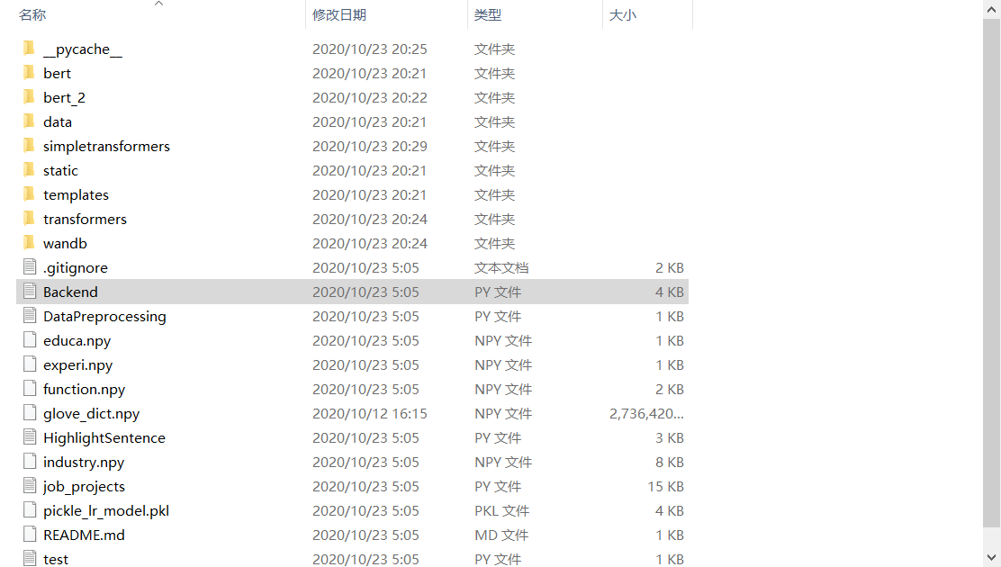

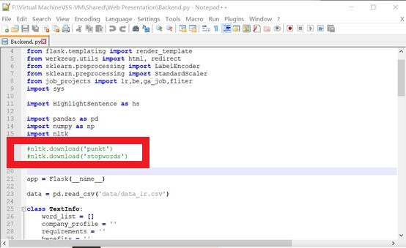

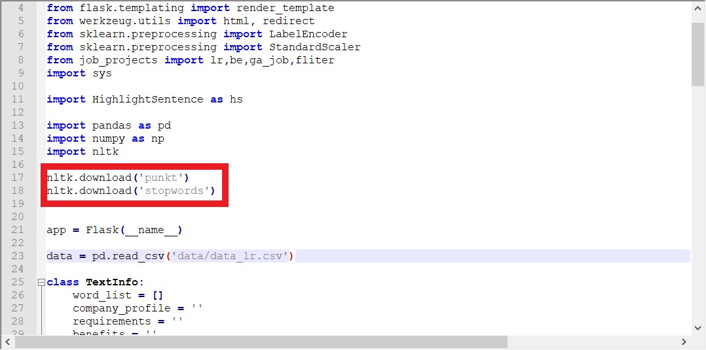

Use cmd and go to the **FraudulentJobClassifier** and use the command: python Backend.py

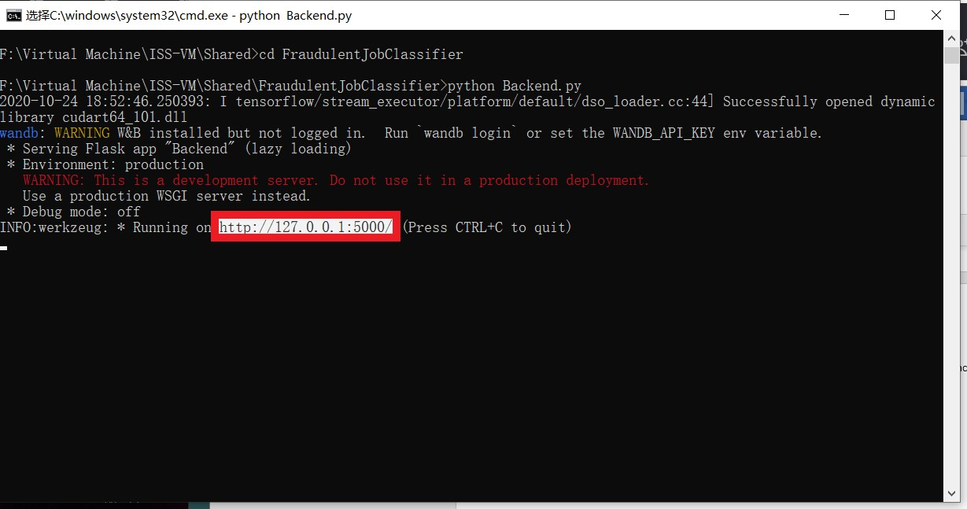

Copy this link to Chrome or Firefox and you can enjoy our system.

After first run, you can choose to note these two codes again:

* **nltk.download('punkt')**
* **nltk.download('stopwords')**

###### Supported Browsers

Firefox, Google Chrome

###### Use the system

When you copy the link to the browser, you can see the start page, please click start button to enter next page.

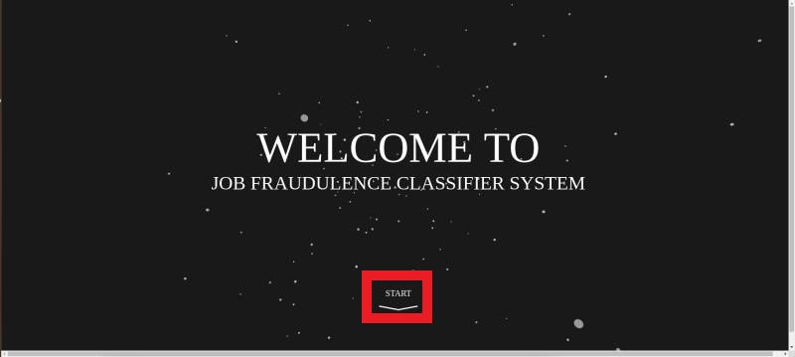

The next page is the form page, you can fill in the job information that you find in internet or you also can click the buttons in the red block to use the example case to test our system. Finish filling and click the summit button, then you can go to next page

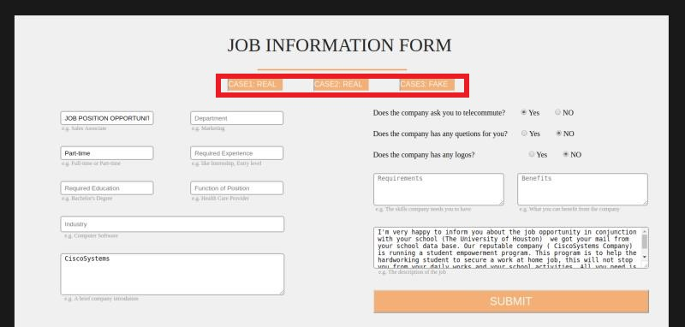

If our system judges the job you provide is a true job, you can click the back button to return to start page. The possibility next to the result text is the confidence about the result.

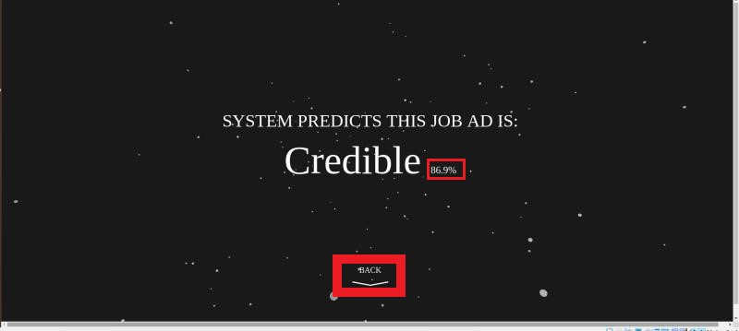

If our system judges the job is a fake job, you can go to see the error report to see why our system say it is fraudulent and you also can click the link below to learn some tips to know whether a job is fake or not.

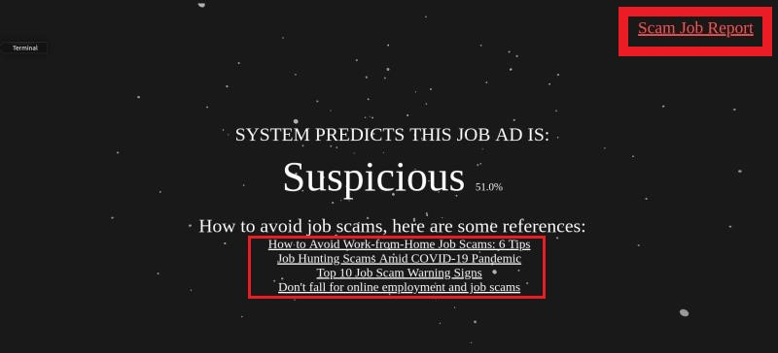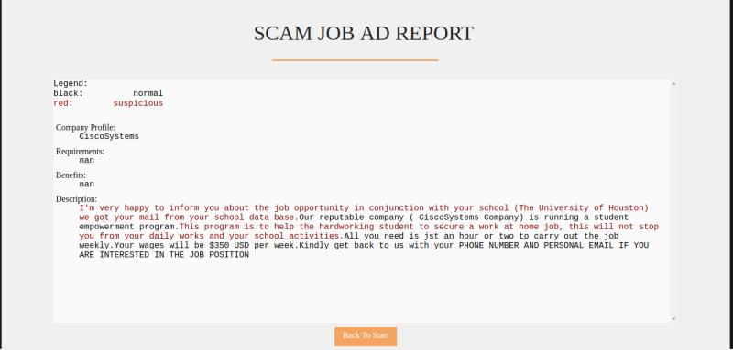

Click the back button and you can go to the start page.